#### 🟦 Kanishk & Roberto – Technical / AI / Data / Implementation

**Q: What AI/NLP technologies will you use?**

* *Keyword:* NLP, sentiment, speech, vision
* *Answer:* PrepOn uses NLP to evaluate clarity, sentiment analysis for tone, speech-to-text with acoustic analysis for pacing, and computer vision for posture and expressions. All models run on secure, cloud APIs for scalability.

**Q: How will you ensure data privacy?**

* *Keyword:* Encryption, FERPA, GDPR
* *Answer:* All recordings are encrypted in transit and at rest, stored on USC-approved secure servers, and fully user-controlled. Students can delete data at any time, ensuring compliance with FERPA and GDPR.

**Q: How will you keep the question database current?**

* *Keyword:* Alumni input, AI trend detection
* *Answer:* Advisors and alumni submit new questions via portal; AI flags emerging topics from job postings and industry reports. This ensures relevance to evolving hiring practices.

**Q: How will the AI give meaningful feedback?**

* *Keyword:* Actionable, specific, progress graphs
* *Answer:* The AI pinpoints filler words, unclear examples, or weak technical answers. It highlights pacing/tone issues and shows improvement trends over time.

**Q: Walk us through rollout phases.**

* *Keyword:* Beta, iteration, expansion
* *Answer:* Phase 1: closed beta with BASA. Phase 2: refine features and scale to MSBA program. Phase 3: expand to MBAs with faculty demos and promotion.

**Q: What resources are needed for the repository?**

* *Keyword:* Career strategists, alumni partnerships
* *Answer:* Small team of career strategists plus alumni/faculty volunteers curate and verify content. Partnerships with USC networks sustain industry-specific quality.

**Q: Estimated development cost & MVP timeline?**

* *Keyword:* $60–80k, 4–6 months
* *Answer:* Using existing AI APIs and cloud infra, MVP can be built for $60–80k in ~4–6 months, covering design, question base, and pilot testing.

**Q: How will you handle tech support during practice?**

* *Keyword:* In-app help, live chat, monitoring
* *Answer:* An in-app help center, live chat, and auto-troubleshooting guides will support users. A small team monitors pilot usage to quickly address issues.

#### **🟨 Aaron – Features / Workflow / Usability**

**Q: What incentives do advisors have?**

* *Keyword:* Efficiency, analytics
* *Answer:* PrepOn extends advisor reach by letting students practice independently while giving advisors performance dashboards, saving time and enhancing impact.

**Q: How will you ensure adoption by students & advisors?**

* *Keyword:* SSO, instant feedback, dashboards
* *Answer:* One-click login with USC credentials, instant AI feedback, and advisor dashboards reduce friction. Faculty endorsements and demos drive engagement.

**Q: How will you get buy-in from the USC administration?**

* *Keyword:* Pilot, early adopters, feedback
* *Answer:* Launch a closed beta with BASA and Career Services. Gather feedback from faculty and student leaders to present refined results to administration.

**Q: What metrics will measure pilot success?**

* *Keyword:* Usage, engagement, confidence
* *Answer:* Metrics include active users, repeat sessions, feedback engagement, confidence surveys, and advisor-tracked placement improvements.

## **🟥 Claudia – Differentiation / Market / Business / Vision**

**Q: How is PrepOn different from Big Interview or VMock?**

* *Keyword:* MSBA-specific, curated, integrated
* *Answer:* PrepOn is built for USC MSBA, with alumni/faculty-curated content, real-time AI analysis of tone and pacing, and direct Career Center integration.

**Q: What prevents larger players from replicating?**

* *Keyword:* Exclusive partnerships, trust, tuning
* *Answer:* Exclusive USC partnerships for proprietary content, MSBA-specific AI tuning, and early trust in the community make replication costly and slow.

**Q: How large is the market & revenue potential?**

* *Keyword:* 200+ programs, multi-million opportunity
* *Answer:* U.S. has 200+ MSBA/MBA programs. Scaling to peer schools and corporate training creates multi-million annual potential with high margins.

**Q: Have you validated demand?**

* *Keyword:* Surveys, advisor input
* *Answer:* USC MSBA surveys and focus groups show strong interest if endorsed by Career Center. Advisors confirm need for scalable 1-on-1 support.

**Q: How will you scale beyond USC?**

* *Keyword:* Replicable model, local curation
* *Answer:* After USC pilot, partner with other universities. Each rollout curates local alumni question banks while core AI engine remains consistent.

**Q: What is your pricing model?**

* *Keyword:* Pilot free, freemium, site license
* *Answer:* USC pilot is free. After success: freemium for individuals, site license for universities, balancing affordability with sustainability.

**Q: How will you fund development & operations?**

* *Keyword:* Grants, awards, licenses
* *Answer:* Seed funding from case comp awards, USC grants, and corporate sponsorships. Sustained by institutional licensing revenue.

**Q: Break-even timeline & ROI?**

* *Keyword:* 18–24 months, scalable margins
* *Answer:* One to two contracts enable break-even within 18–24 months. Low marginal costs and cloud infra drive strong ROI as expansion grows.

**Q: How will you track student outcomes?**

* *Keyword:* Scores, confidence, placement data
* *Answer:* Metrics include AI performance scores, confidence surveys, and placement rates tracked by Career Center.

**Q: Could PrepOn expand to other programs?**

* *Keyword:* Modular design, rebranding
* *Answer:* Yes, easy rebrand and customize question banks for MBAs, engineers, or corporates while reusing AI core.

**Q: How will you evolve with generative AI?**

* *Keyword:* Conversational AI, multilingual, predictive
* *Answer:* Future includes live AI interviewers, multilingual practice, and predictive analytics for industry-critical skills.

[**Our Slide is here**](https://www.canva.com/design/DAGz9JpuIn0/xRPWbKl1Hr7angCP4Gud7Q/edit)

**(1) Review your process of empathizing with potential users including Business Need, Ideation and Sources**

**Slide 1, Slide 2 - Roberto**

Intro + client & business need

**Slide 3 - Claudia**

Ideation process

**(2) Share methodology in product design with basic product requirements documentation (PRD) and Basic Product Wireframe**

**Slide 4 - Aaron**

Wireframe

**Slide 5 - Kanishk**

Methodology

**(3) Prototype the app (either through a simulation on Figma or a low-code development tool). Showcase images, functionality and value creation**

**Slide 6 - Le**

Landing page

**Slide 7 - Claudia**

Practice session screen

**Slide 8 - Kaiwen**

AI grade feedback

**Slide 9 - Steven**

Progress Dashboard

**(4) Provide an initial plan for Implementation to roll out the product and change user behavior to utilize the App.**

**Slide 10 - Kaiwen, Rona**

Rollout phases & driving behavior change

**Slide 11 - Aaron**

Value proposition

**Client: MSBA community**

**How to break down “MSBA Community”:**

1. International vs domestic
   1. 1st vs 2nd
   2. age
2. Alumni
   1. International vs domestic
3. Faculty
4. Profile Background
   1. Age
   2. Industry
   3. Demographics
   4. Roles
5. BASA

1). Brainstorm problems for international students: struggle with Environmental Adaptation

**Brainstorm some problems currently USC MSBA has:**

1. Elective class visibility (most ppl disliked STARS report - hard to read/interpret)
2. Connectivity w/ alumni (USC MSBA version of Linkedin)
3. User Interface for [BASA](https://clubs.marshall.usc.edu/basa/home/) (current BASA website lacks info)
4. Finding Research/Project Opportunities ⇔ project app (hard to find RA job on handshake/ twelve20)
5. Personalizing Mentorship
6. Time management -> personalized schedule

|  | **Problems** | **Pros** | **Cons** | **Target audience** |
| --- | --- | --- | --- | --- |
| 1 | Elective class visibility (most ppl disliked STARS report - hard to read/interpret) | 1. Simple idea, easy to get data 2. Filters flexibility (semester; waitlist..) | 1. How to sync data 2. Seasonality (need to update 3. Already a solution there | 1. advisors |
| 2 | Connectivity w/ alumni (USC MSBA version of Linkedin) | 1. Reachability 2. Convenience/ personalization | 1. Already has linkedin; 12twenty 2. Find alum to sign up 3. Inactivity | 1. All msba students |
| 3 | User Interface for [BASA](https://clubs.marshall.usc.edu/basa/home/) (current BASA website lacks info) | 1. Lot of problems | 1. Too broad[superapp] | 1. All msba students 2. BASA board |
| 4 | Finding Research/Project Opportunities ⇔ project app (hard to find RA job on handshake/ twelve20) |  | 1. Apps already exist |  |
| 5 | Personalizing Mentorship  (BASA tinder) |  | 1. Too simple if less filters r used 2. More filters will lead to no matches[small sample] |  |
| 6 | Time management -> personalized schedule | 1. More use | 1. Too complex[building] | All msba students (both first second year) |

Potential areas to play around:

1. Career development: job <- practice interview <- practice
2. BASA: opportunities <- mentorship program

**Final Topic:**  
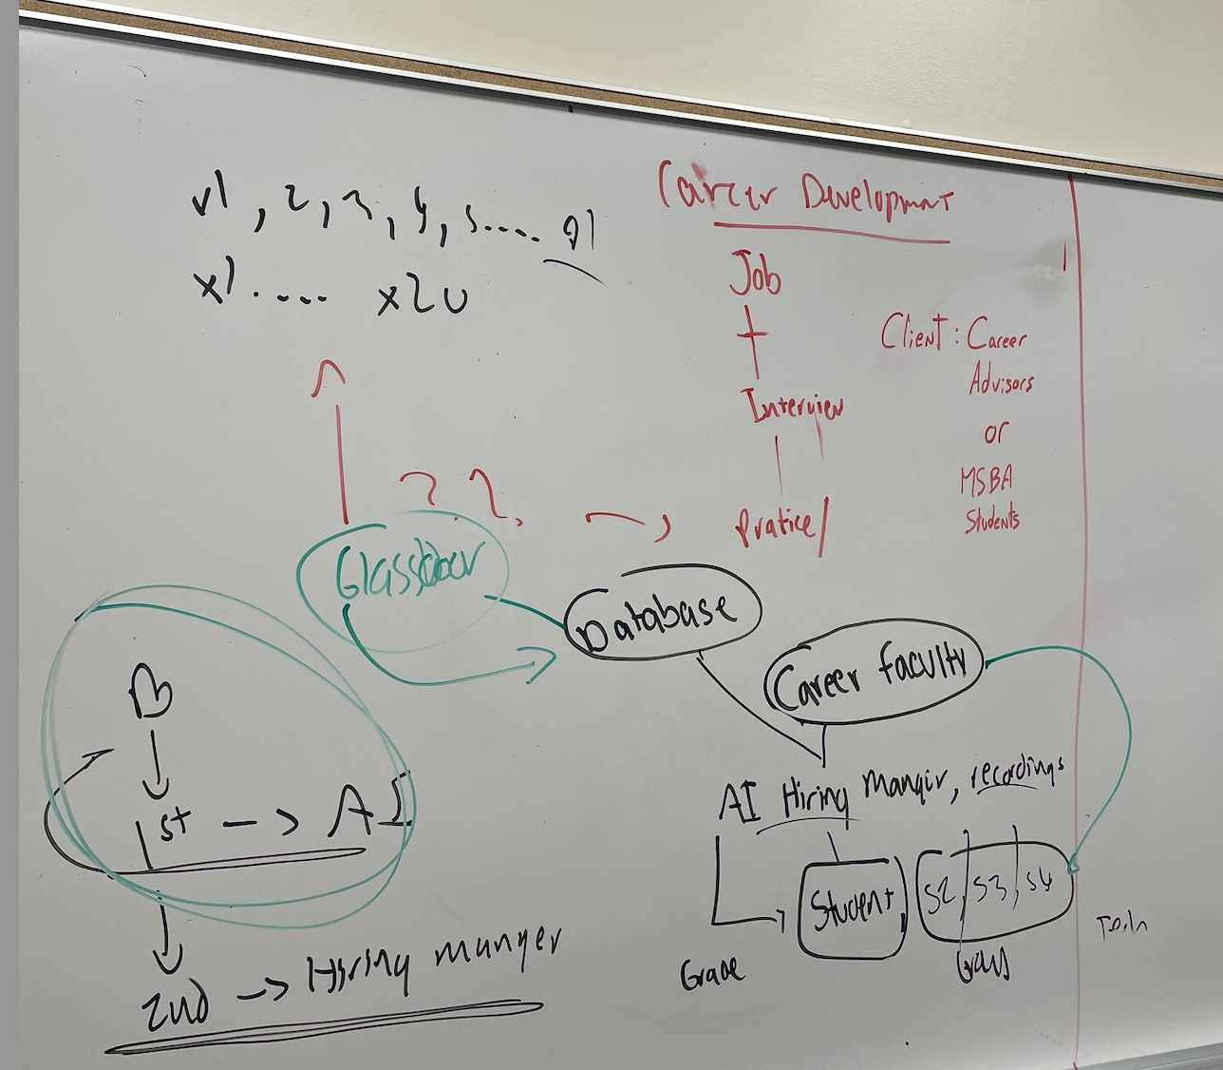

**Target:** USC MSBA Community

**Goal:** Benefit as many people in this community as possible

**Traceback to brainstorm:**

In terms of career development, our thinking process is:

Almost Everyone here aims at finding a job for next summer/ after graduation

-> need to practice interview! -> so how to practice???

**Then visualize our app:**

Glassdoor database + career faculty + faculty

||

Student_Interview Group_Interview Tech_Interview

(2nd phase (3rd phase) (though process unlike LeetCode)

with hiring manager)

Problem:

Why:

Faculty limited with time

Not flexible hard personalizing

Not enough practice

Other products are too general or expensive

how /what:

Out features:

Options for interviews (behavioral, group, tech, case)

Respiratory of all interviews with scores

### **Cover Slide**

**Title:** USC MSBA AI Interview Practice App  
 **Subtitle:** Empowering Career Success with AI & NLP  
 **Footer:** Team #X | 6th Annual USC Marshall MSBA Global AI Case Competition 2025

👉 *Pitch Line:* “Today we present our solution designed to create real, lasting value for the USC MSBA community: an AI-powered interview practice app.”

### **Part 1 – Empathize**

**Slide 1 – The Client: USC MSBA Community & Business Need**

* Diverse: domestic & international students, first- & second-year.
* Career-driven: most students aim for jobs in consulting, tech, finance, and analytics.
* Challenge: intense competition + limited career prep resources.

👉 *Pitch Line:* “Our client is the USC MSBA community, a diverse, global, career-focused group facing high-pressure recruiting cycles.”

**Slide 2 – Business Need**

* Pain Points:  
  1. Lack of personalized, role-specific interview practice.
  2. Limited faculty availability.
  3. Market tools are too generic or too expensive.
* Result: students feel underprepared for competitive job markets.

👉 *Pitch Line:* “We identified a clear business need: scalable, personalized, and affordable interview practice tailored to MSBA students.”

**Slide 3 – Ideation Sources**

* Surveys & conversations with peers.
* Input from faculty advisors.
* Benchmarking existing tools (Glassdoor, Big Interview, LeetCode).
* Brainstorming workshops.

👉 *Pitch Line:* “Through empathy research and ideation, we validated that this problem is widely felt, and no existing solution fully addresses it.”

### **Part 2 – Product Design**

**Slide 4 – Basic PRD (Product Requirements Document)**

* **Users:** MSBA students.
* **Core Features:**
  1. Interview type selection.
  2. AI-generated questions & real-time NLP feedback.
  3. Score breakdown & progress tracker.
* **Success Metrics:** adoption rate, sessions completed, confidence scores.

👉 *Pitch Line:* “Our PRD clearly outlines who the product serves, what it delivers, and how we measure success.”

**Slide 5 – Wireframe (User Journey)**

* Flow: Home → Select Interview Type → Practice Session → AI Feedback → Dashboard.
* Visual: black-and-white wireframes with arrows.

👉 *Pitch Line:* “We translated our requirements into a simple, intuitive flow that mirrors the student’s learning journey.”

### **Part 3 – Prototype**

**Slide 6 – Landing Page & Selection**

* Figma mockups: homepage + interview type selection.
* Caption: “Quick access, tailored to career goals.”

👉 *Pitch Line:* “The app starts with a clean interface and lets students select behavioral, technical, case, or group interviews.”

**Slide 7 – Practice Session Screen**

* Figma mockup: question display + microphone icon + text box.
* Caption: “Flexible practice in text or voice.”

👉 *Pitch Line:* “Users can practice by typing or speaking their answers, making it realistic and versatile.”

**Slide 8 – AI Feedback Screen**

* Figma mockup: structured feedback with scores by category.
* Caption: “Immediate, actionable insights.”

👉 *Pitch Line:* “Our NLP engine provides targeted feedback on structure, clarity, tone, and delivery.”

**Slide 9 – Progress Dashboard**

* Figma mockup: improvement graph + history of sessions.
* Caption: “Track growth and build confidence.”

👉 *Pitch Line:* “The dashboard motivates users by showing measurable progress over time.”

### **Part 4 – Implementation Plan & Closing**

**Slide 10 – Rollout Phases**

* **Phase 1:** Pilot within MSBA beta group.
* **Phase 2:** Adoption via BASA, career workshops, gamification.
* **Phase 3:** Expansion to alumni and other programs.

👉 *Pitch Line:* “We propose a phased rollout, starting small and expanding adoption across the Marshall ecosystem.”

**Slide 11 – Driving Behavior Change**

* Make it **easy**: mobile-friendly, one-click practice.
* Make it **rewarding**: badges, streaks, peer challenges.
* Make it **embedded**: integrated into career prep events.

👉 *Pitch Line:* “Behavior change comes from ease of use, rewarding progress, and embedding the app into the MSBA experience.”

### **Closing**

**Slide 12 – Value Creation & Call to Action**

* **Key Value:** scalable, personalized, accessible interview prep.
* **Impact:** stronger student outcomes, improved job readiness, tighter community.
* Tagline: *“AI turns practice into success.”*

👉 *Pitch Line:* “By combining empathy, design, and AI, our app creates significant value for the MSBA community—turning practice into success.”

## 

## 

## 

## **Slide Title: Ideation Process**

**Research Inputs**

* **Peer feedback:** Surveys and informal interviews with MSBA classmates on recruiting challenges.
* **Faculty advisors:** Confirmed limited capacity for personalized mock interviews.
* **Benchmarking:** Compared existing tools (Glassdoor, Big Interview, LeetCode) and found them too generic or costly.
* **Brainstorming workshops:** Explored multiple MSBA pain points (electives, alumni connectivity, mentorship, career prep).

**Insights Gained**

* Almost everyone’s top priority is **finding a job after graduation**.
* Interview practice is critical but **not flexible, not personalized, and not scalable** under current resources.
* Strong opportunity to leverage **AI/NLP** to create a career-focused, affordable, and community-specific solution.

**Problem Statement**

*“MSBA students need an effective, accessible, and tailored way to practice interviews that goes beyond existing resources.”*

## **Slide Title: Implementation Plan & Driving Behavior Change**

📦 Rollout Strategy (Phased Approach)

- 🟢 Phase 1 – Pilot (Weeks 1–3)  
  • Launch a closed beta with 15–20 MSBA students  
  • Collect feedback on functionality, UI, and feedback accuracy  
  • Measure usage and adjust based on initial results

- 🟡 Phase 2 – Adoption (Weeks 4–8)  
  • Partner with BASA and Career Services for promotion  
  • Integrate into mock interview workshops and recruiting prep events  
  • Introduce gamification: badges, streaks, and progress leaderboards

- 🔵 Phase 3 – Expansion (Post-launch)  
  • Invite alumni and faculty to contribute industry-specific questions  
  • Extend access to Marshall MBA and other grad programs  
  • Explore integration with LinkedIn or USC login systems

🧠 Behavior Change Strategy

- Make It Easy  
  • Seamless web/mobile access  
  • One-click “Start Practice” button

- Make It Rewarding  
  • Instant AI feedback for rapid improvement  
  • Visual progress tracking to boost motivation  
  • Gamification to encourage consistency

- Make It Embedded  
  • Use in classroom settings (e.g., for case-based courses)  
  • Career Center recommendation as part of interview prep  
  • Promote during student onboarding and alumni panels

📈 Goal: Establish this app as a default practice tool that becomes part of the MSBA culture — not just a one-time resource.